16th Sunday after Pentecost – 9/13/2026

Prelude—Welcome—Announcements

Today’s gospel passage is about receiving forgiveness and then showing forgiveness to others.

Call to Worship

Forgiveness is what God would have us do always. In the prayer Jesus taught us, we say, forgive us our trespasses, as we forgive those who trespass us.

We ask for forgiveness, God, when we pray The Lord’s Prayer. Yet, our actions outside of the walls of this church do not always show we remember our prayers inside the walls of this church.

Help us to remember the passage today, this day and all the days of our lives.

We pray this in the name of Jesus, your son.

Prayer of Confession

Heavenly Father, we ask that you strengthen our desire to forgive others. Help us to look at forgiveness as an act to begin a new with others, rather than looking at staying away from others that hurt us.

Hymn #560 Help Us Accept Each Other

The word of God

Gospel lesson………………………………………………………Matthew 18:21-35

The word of God, for the people of God. Thanks be to God

Children’s Time

Hymn #557 Blest Be the Tie That Binds

Message

Prayers for the People—The Lord’s Prayer

Offering/Doxology/Prayer

Departing Hymn #2152 Change My Heart, O God

Departing words

Jesus asked the Father to forgive them, for they do not know what they are doing. When heavenly actions become suppressed because of the earthly distractions we encounter, try to remember today’s passage. The servant asked for forgiveness, yet demanded payment for what was owed him. As we depart today’s service, let us demonstrate forgiveness as our first thought, if we want the world to see the loving God we know by our actions.

Postlude—you are welcome to remain to listen to the postlude.

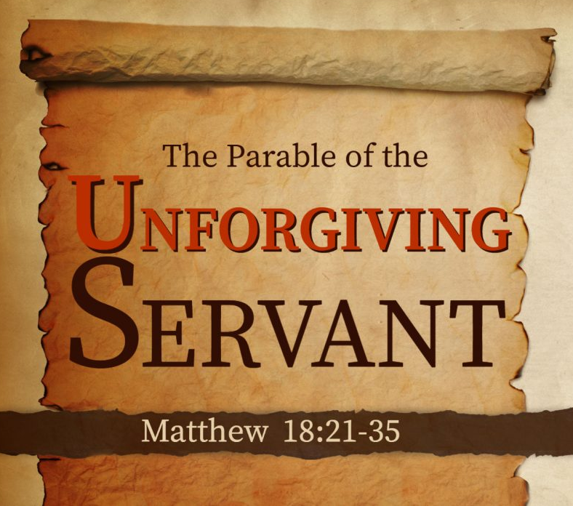

September 13, 2026

